**Energy Forms & Changes***PhET Simulation*

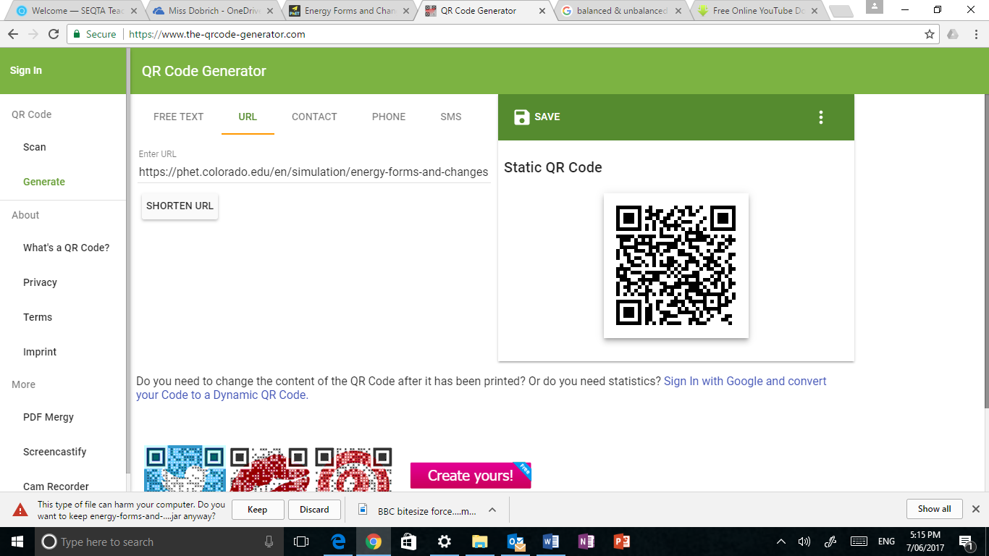***(ANSWERS)***

**GO TO:** PhET – Energy Forms & Changes  
<https://phet.colorado.edu/en/simulation/energy-forms-and-changes>

In this simulation you will be able to “see” several different forms of energy and the changes (transfers) that can occur between them. You are also able to work with a system where you can manipulate the energy input, observe the process of electrical energy generation and manipulate the output.

**INTRO**

1. Click on the **“Intro” tab**.
2. 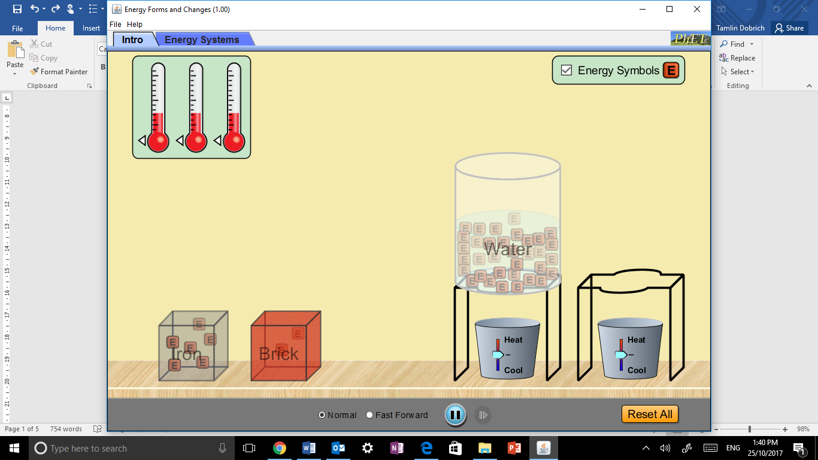Be sure to click the **“Energy Symbols” box** so the different types of energy will be visible throughout the process.

**INVESTIGATION QUESTIONS**

1. Drag the water container over the temperature controller as shown 🡪

Compare how “energy” moves in water at high temperatures with that of low temperature.

***High temperatures –*** *There is more energy and it moves more rapidly and more freely.*

***Low temperatures*** *– There is less energy and it moves less rapidly and less freely.*

1. In which direction does the energy move as it heat up?  ***Up***

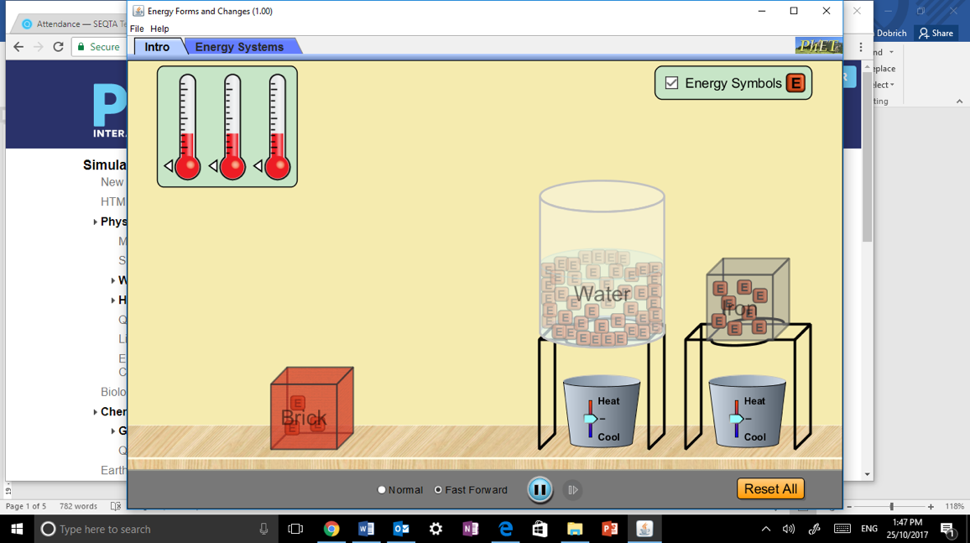Propose a reason why it moves in this direction.

***Heat rises*** *– adding heat causes matter to become less dense allowing it to rise.*

1. Drag the iron block over the other temperature controller 🡪

Compare how water and iron transfer “energy”.

***Initially, heat energy escapes faster from the water than the iron block.***

**ENERGY SYSTEMS**

1. Click on the **“Energy Systems” tab**.
2. Be sure to click the **“Energy Symbols” box** so the different types of energy will be visible throughout the process.

**GETTING FAMILIAR WITH THE OPTIONS**

Experiment with the different source, generation and output options – there are many combinations to play with – then complete the questions below.

|  |  |  |  |  |  |  |  |  |  |
| --- | --- | --- | --- | --- | --- | --- | --- | --- | --- |
| **Energy Input Options** | | | | **Energy Generators** | | **Energy Output Options** | | | |
|  |  |  |  |  |  |  |  |  |  |
| **Faucet** | **Sun** | **Kettle** | **Bike** | **Turbine** | **Solar Panel** | **Water Heater** | **Regular Bulb** | **Fluorescent Bulb** | **Fan** |

1. Which **energy sources (input)** can cause the turbine (wooden wheel) to spin and generate electrical energy?

***Faucet***

***Kettle***

***Bike***

1. Which **energy sources (input)** can cause the solar panels to generate electrical energy?

***Sun*** *(only)*

1. Which **energy output** objects work with the turbine?

***Water heater***

***Regular bulb***

***Fluorescent bulb***

***Fan***

1. Which **energy output** objects work with the solar panels?

***Water heater***

***Regular bulb***

***Fluorescent bulb***

***Fan***

1. What happens to the amount of electrical energy that is generated when the…  
   1. Faucet is on high: ***More energy is produced***
   2. Faucet is on low: ***Less energy is produced***
   3. There are no clouds: ***More energy is produced***
   4. There are lots of clouds: ***Less energy is produced***
   5. Low heat on the kettle: ***Less energy is produced***
   6. High heat on the kettle: ***More energy is produced***
   7. The girl pedals slowly: ***Less energy is produced***
   8. The girl pedals quickly: ***More energy is produced***
2. Explain why the cyclist must be fed in order to continue to pedal.

***As the cyclist is pedalling, she is using up the stored energy inside her body.   
  
Eventually this energy runs out and must be replenished with more chemical energy from food.***

1. The Law of conservation of energy stated that ***energy cannot be created or destroyed, only transferred and transformed.***

**EXPLORING ENERGY TRANSFER**

Set up your system as shown in the picture. Let it run for a while and then complete the sentences using the energy symbols to help you “see” the flow of energy within each system.

**ACTIVITY 1: Turbine moved by medium water flow from faucet with a hot water system**

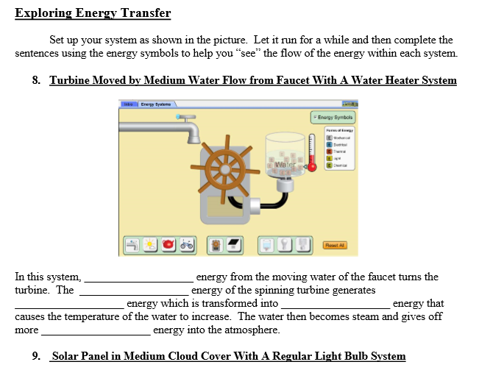

In this system ***mechanical*** energy from the moving water of the faucet turns the turbine. The ***mechanical*** energy of the spinning turbine generates ***electrical*** energy which is transformed into ***heat/thermal*** energy that causes the temperature of the water to increase. The water then becomes steam and gives off more ***heat/thermal*** energy into the atmosphere.

**ACTIVITY 2: Solar panel in medium cloud cover with a regular light bulb system.**

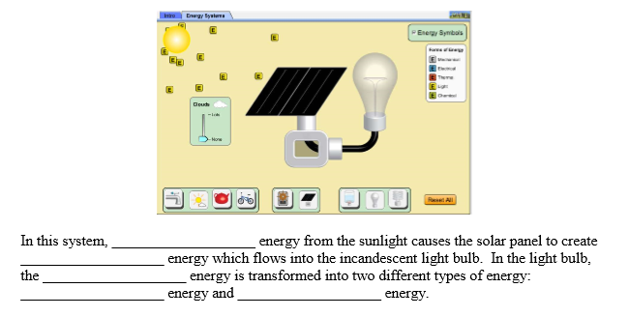

In this system, ***light*** energy from the sunlight causes the solar panel to create ***electrical*** energy which flows into the incandescent light bulb. In the light bulb, the ***electrical*** energy in transformed into two different types of energy: ***light*** energy and ***heat/thermal*** energy.

**ACTIVITY 3: Turbine moved by steam from medium heat kettle with a water heater system.**

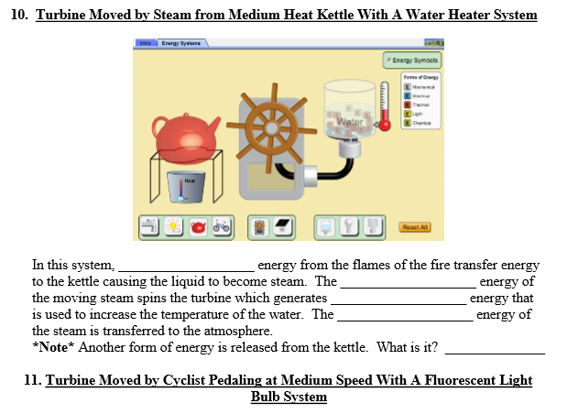

In this system, ***heat/thermal*** energy from the flames of the fire transfer energy to the kettle causing the liquid to become steam. The ***mechanical*** energy of the moving steam spins the turbine which generates ***electrical*** energy that is used to increase the temperature of the water. The ***heat/thermal*** energy of the steam is transferred to the atmosphere.

**NOTE:** another form of energy is release from the kettle. What is it? ***Sound energy***

**ACTIVITY 4: Turbine moved by cyclist pedalling at medium speed with a fluorescent light bulb system.**

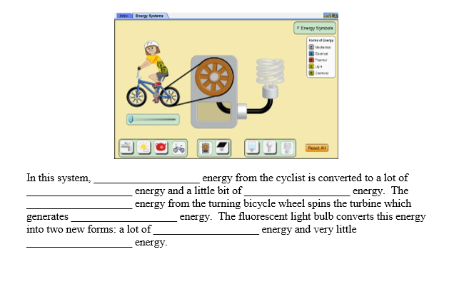

In this system, ***chemical*** energy from the cyclist is converted to a lot of ***mechanical*** energy and little bit of ***heat/thermal*** energy. The ***mechanical*** energy from the turning bicycle wheel spins the turbine which generates ***electrical*** energy. The fluorescent light bulb converts this energy into two new forms: a lot of ***light*** energy and very little ***heat/thermal*** energy.

**ACTIVITY 5: Investigation questions**

1. Switch out the fluorescent bulb with the regular bulb and observe the energy output. What do you notice about the difference in energy and output of these two bulbs?

***The regular light bulb produces far more (wasted) heat energy than the fluorescent light bulb.***

1. In your opinion, which light bulb is more efficient? ***The fluorescent light bulb***
2. How do you know this?   
   ***The purpose of the bulbs is to produce light not heat.***

***More of the energy going into the fluorescent bulb is being converted into light than the regular light bulb.***

1. What common form of energy (not including kinetic or potential) is not included in the “Energy Symbols” key that would normally be present in these examples?   
     
   ***Sound energy***
2. Look carefully at each of the four systems shown above. Knowing what we have discussed about energy conversion, identify (list) at least three different places where this form of energy (question 2) should be “produced”.

***Sound energy would be produced by:***

* *The running water of the facet/tap*
* *The steam of the kettle*
* *The “huffing-and-puffing” of the cyclist*
* *The turning of the turbine*
* *The “humming” of electricity through wires or in light bulbs*
* *The bubbling of boiling water in the water heater*
* *The turning blades of the fan*

1. In the space below, explain why this simulation is a good way to illustrate the Law of Conservation of Energy. Use specific examples to support your answer.

*The* ***Law of Conservation of Energy*** *states that energy cannot be created or destroyed, only transferred and transformed. In this simulation, we observed how energy is transferred and transformed from one state to another. For example, mechanical energy from a facet is transferred to mechanical energy in a turbine, this is then converted into electrical energy which powers a light bulb to produce light energy. No energy is lost in the process however, it is often wasted in the form of heat.*